KANEKTOK NEWS

Always Changing News for the Always Changing River

The New School
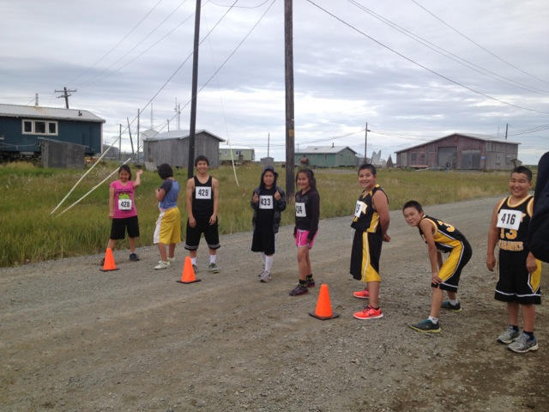
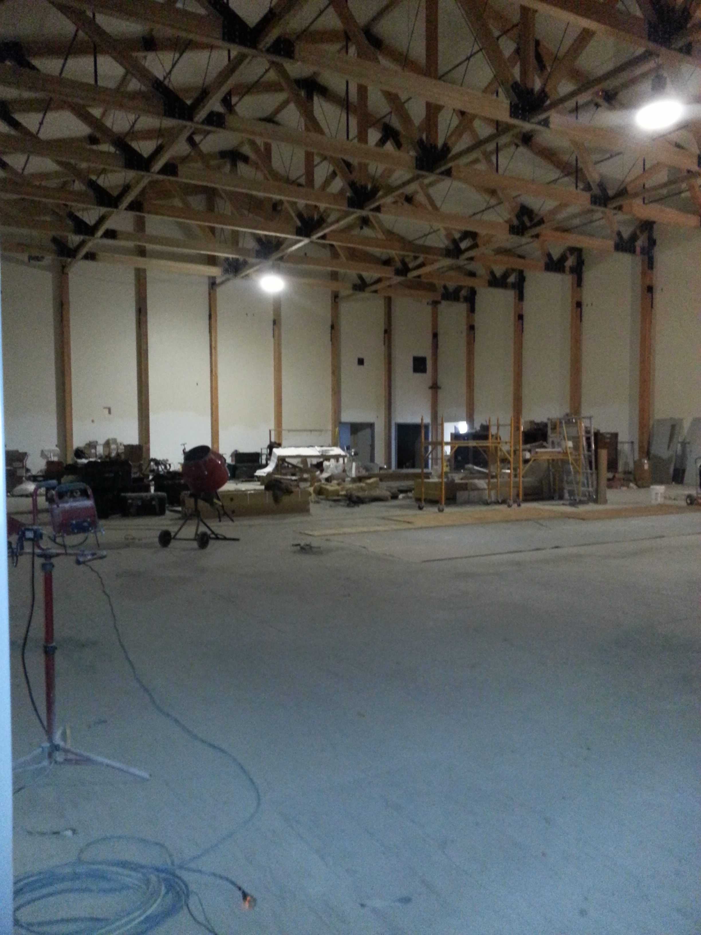
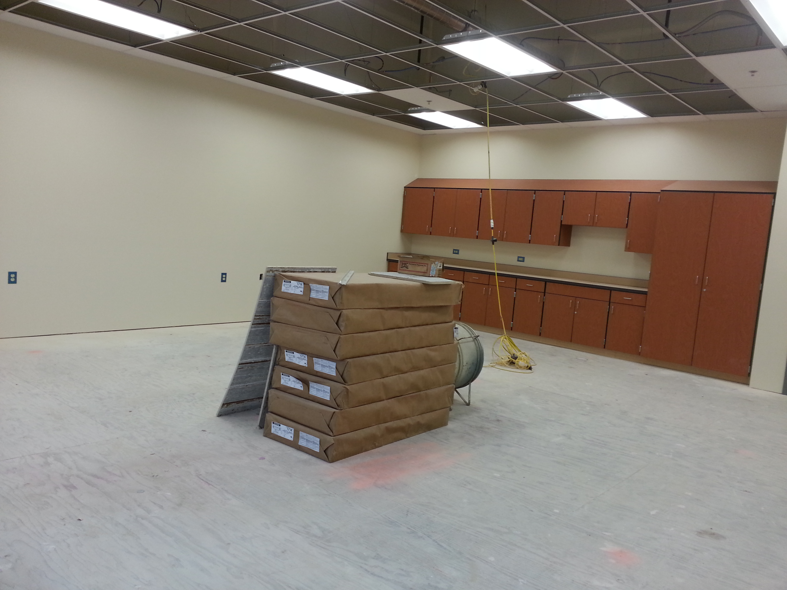
This year of 2014 in Quinhagak there’s been changes during this summer near Kuinerrarmiut Elitnaurviat. They are extending our school for the high school students. We interviewed one of the workers and asked a few questions. And these were the workers who started building the new side on June 2013. Inside the building there’s going to be VPW wall coverage, carpet floors, sinks in the classrooms, and the gym floor is going to be natural maple and the rest is paint. There are going to be twelve new rooms, an art room, science lab, and normal classroom. They’re also building a new playground. On the older side of the school they are making a new kindergarten classroom. They have 25 people working on this and the other half of the people working are from the local community. They will transfer the high school side during Christmas break. The time that it will be open and be used is when we get back from our Christmas break, sometime in January. The school is going to have a new boiler house and electrical room. Also around the building there’s the new fourplex for the teachers and the trailer house that the construction workers are camping in. They are expecting to be done in the year of 2015.
Figure 1 New Gym in Progress
Figure 2 New Classrooms

QUINHAGAK 2014-15 CROSS COUNTRY
QUINHAGAK, Ak-The Quinhagak cross country started on the 14th of August. Quinhagak will host a home meet on the 12th of September and there will also be a Salmon Run during the cross-country meet. There are 8 junior high students and 11 high school students participating in the event. They practice 5 days a week. It depends on how far they run, anywhere from 1 mile to 4 miles.

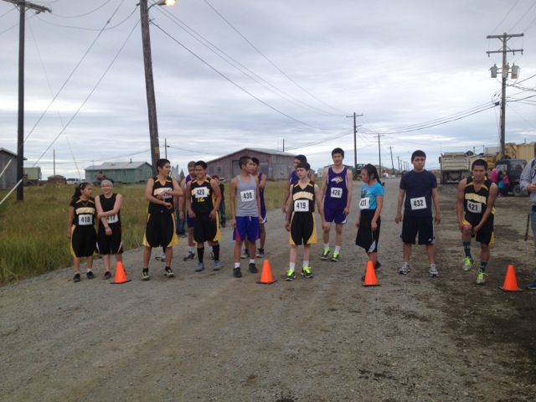
Alexie Galila: Alexie see’s the sport as in getting on shape for basketball and wrestling. Alexie says that him and his team are hoping to go to Togiak; Larry is going to check the financial budget for the team to travel. His favorite thing about practice is running with his close friends and having fun while he is getting in shape. He is excited to travel because he can go to places he didn’t go to before around the region.

Schedule

Aug 29-30: Kwethluk
Aug 30: Toksook Bay
Sept 6: Akiachak
Sept 12: Quinhagak
Sept 13: Akula
Sept 20: Bethel Regional High School
Regional’s Sept 27: Chevak
State Cross Country Oct 4: Bartlett High School

The New Teachers of The Q
By: Larissa Strunk, Shannon Bell, Melissa Nicori, and Marissa Jones

QUINHAGAK, AK – If you have gone to the school recently, you may have seen some new faces and were probably wondering who they were. These five people are the new members of the Kuinerrarmiut Elitnaurviat staff and their names are: Mrs. Peggy Price, Mr. Vincent Villella, Mr. Alex Andrews, Ms. Heather Vogwill, and Ms. Melanie Richmond.

Mrs. Price is the new principal of our school. Before coming here, she was the previous principal of Akiachak. Mrs. Price has a home in Idaho with her husband and they both have six children and nineteen grandchildren. This year she’s looking forward to getting to know all of the students and the challenges she thinks she will face this year is being apart from her family for a long period of time.

Mr. Andrews is the high school literature, history, government, and P.E. teacher. He became a teacher because he loves to read and write and wants to pass that passion along to others, especially his students. His first impression of Quinhagak was how nice everyone is. “As you walk down the road people will wave to you even if they don’t know you. Children will come up and ask who you are.” This year he looks forward to getting to know the students better and connecting with them. He also looks forward to becoming more involved in the community and learning about the Yupik language and culture.

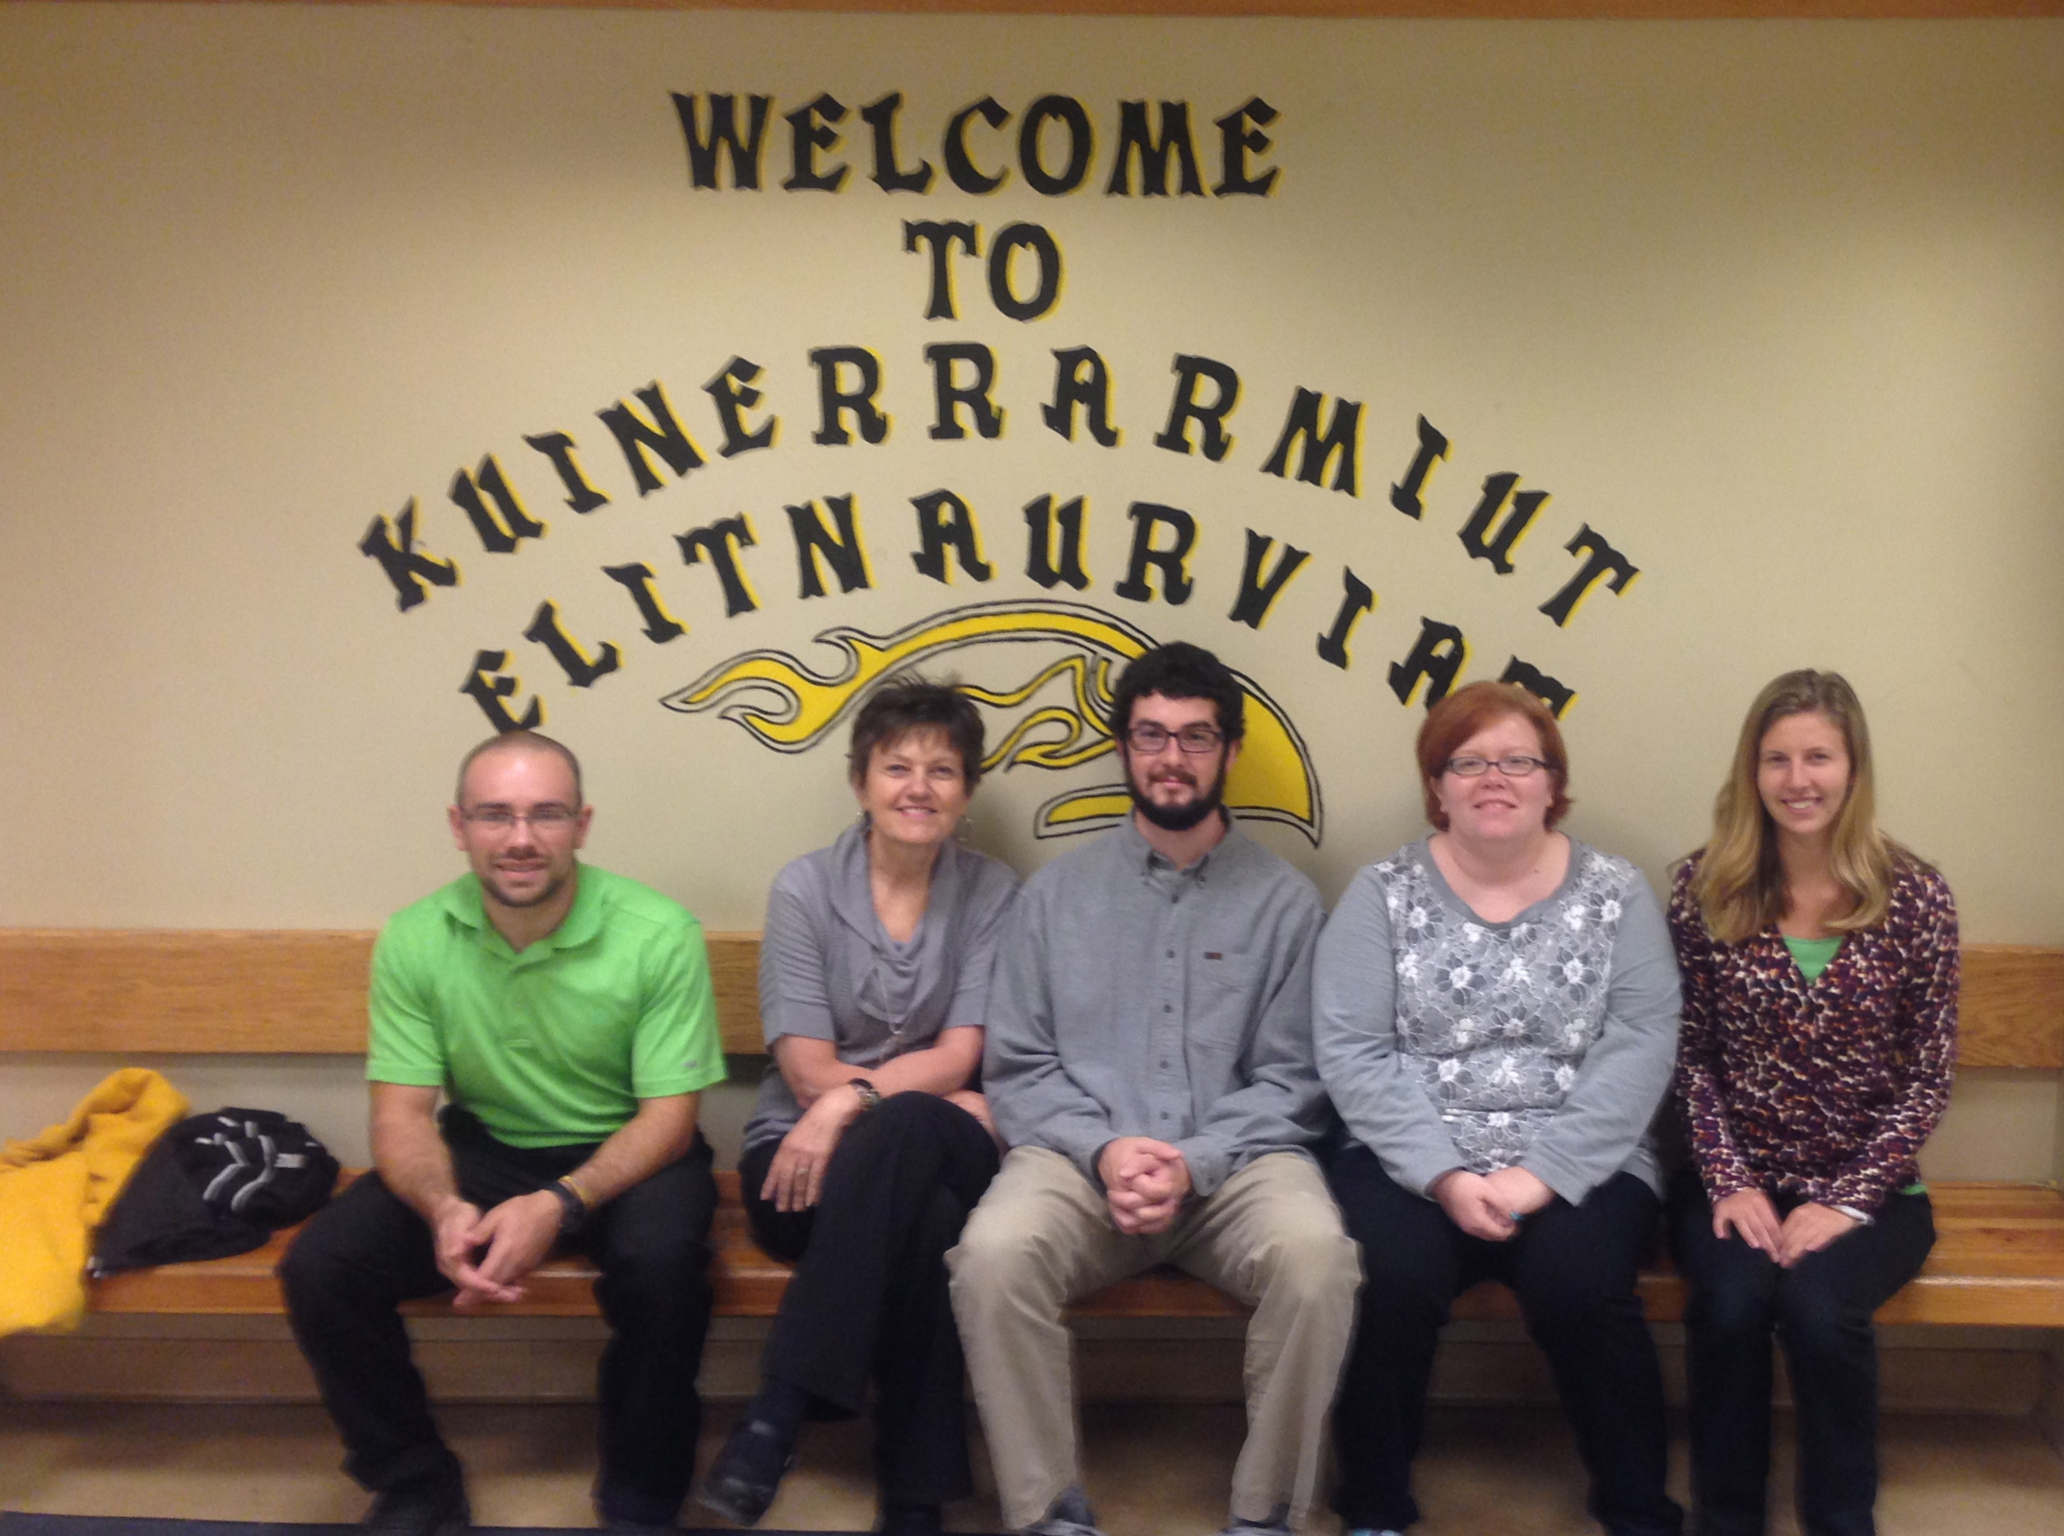
From left to right: Mr. Villella, Mrs. Price, Mr. Andrews, Ms. Richmond, and Ms. Vogwill. Photo By: Timothy Hurst

Mr. Villella is the high school math, and science teacher. This previous year he had taught in Kenya, Africa and it is his first time teaching in an American classroom. The reason why he wanted to become a teacher is because he wanted to interact with people and also work with science instead of being alone all day in a lab. Mr. Villella is looking forward to having his own classroom and teaching the American curriculum. He says, “Teaching in itself is an adventure.”

Ms. Vogwill is the new 6th grade teacher that is from Idaho. Ms. Vogwill wanted to teach because she loves inspiring children. She loves to travel and learn about unique cultures. When Vogwill got here, she was excited because she is rarely able to go to the ocean and thought the mountains were incredible. This year she is looking forward to the adventures she will have as a first year teacher while making those memories here in Alaska.
Ms. Richmond teaches the 5th grade she is from a small town called Hodgenville, Kentucky Ms. Richmond was inspired by her own teachers to become a teacher and wanted to help others the way they taught her. When she first came to Quinhagak, she was impressed that everything is so close together because she grew up in a place where everything was separated by farms. This year, Ms. Richmond is looking forward to learning the Yupik language and hearing it first-hand.

We hope you enjoy the rest of your year here in Quinhagak and have a great experience with the Ysupik culture. Go Seahawks!

